PHASE 8: PROJECT DEMONSTRATION PHASE

Project Demonstration
The completed project is demonstrated in the ServiceNow platform.

Demonstration Flow
Step 1: Show the Excel spreadsheet containing employee data.
Step 2: Show the Employee Test custom table and its fields.
Step 3: Show the Employee Import Import Set table.
Step 4: Show the Sample Spreadsheet Import Transform Map.
Step 5: Demonstrate the source-to-target field mapping.
Step 6: Run the Transform and show the successfully imported employee records.
Step 7: Demonstrate Coalesce by importing existing employee data and showing that duplicate records are not created.
Step 8: Show the Transform History containing inserted, updated and ignored records.
Step 9: Demonstrate the three reports:
- Employees by Department
- Employees by Location
- Employee List Report
Step 10: Finally, demonstrate the Employee Analytics Dashboard, where the reports are displayed together.

Final Outcome
The project successfully demonstrates an employee data import and management process using ServiceNow Import Sets and Transform Maps. The final dashboard provides a centralized view of employee information and related reports.
Create Reports on Employee Test Table
Navigation Steps :
- Open All menus, Search for Reports.
- Under Usage and governance Select Reports.
- Click the New button to create a new report.
- Create 3 Reports as follows.
Report 1: Employees by Department
- In Data
- Report name : Employees by Department.
- Source Type : Table.
- Table : Employee Test, Now click the Next button.
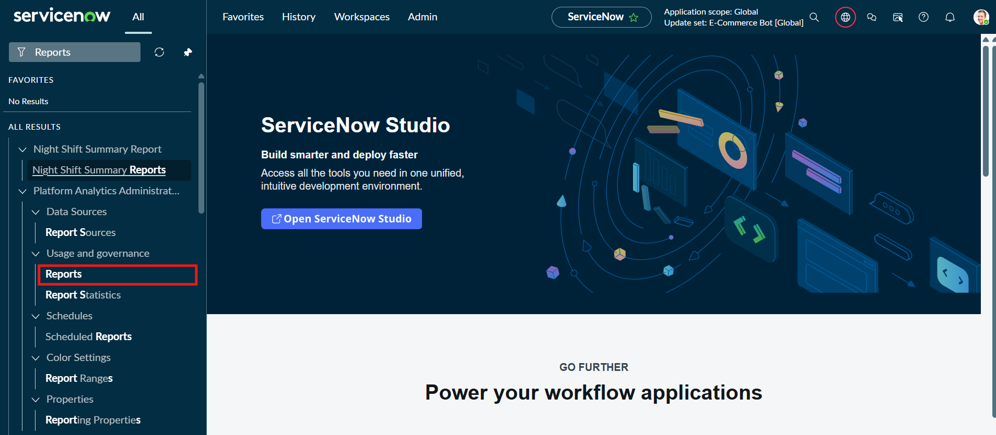
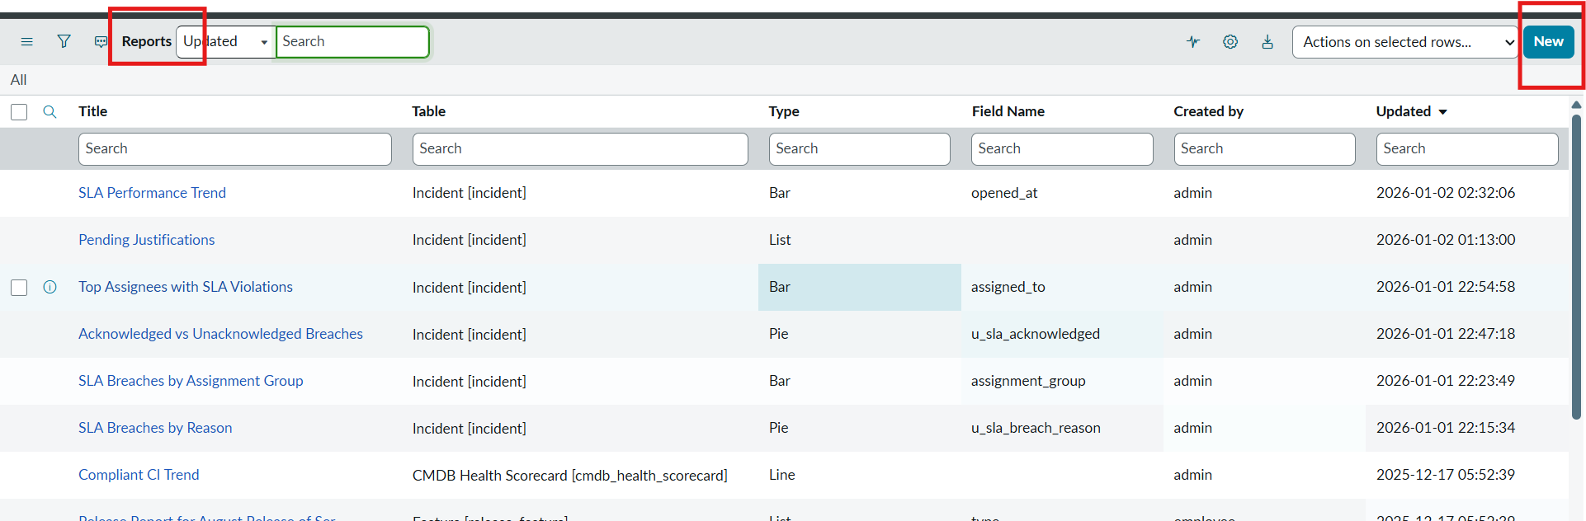

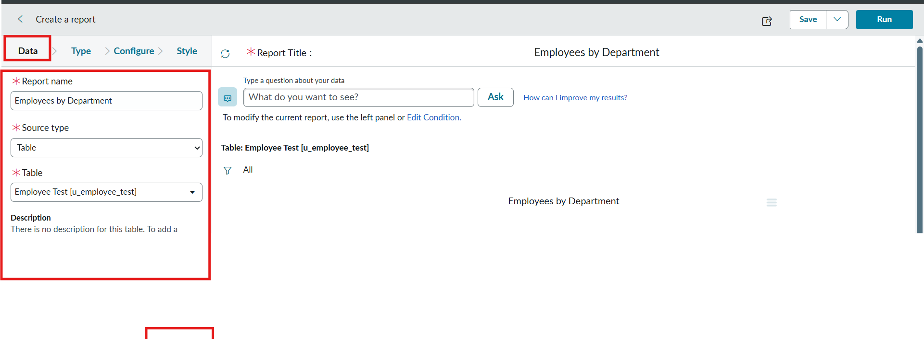
- Now after Clicking next in type Select Pie chart .
- And click the next button.
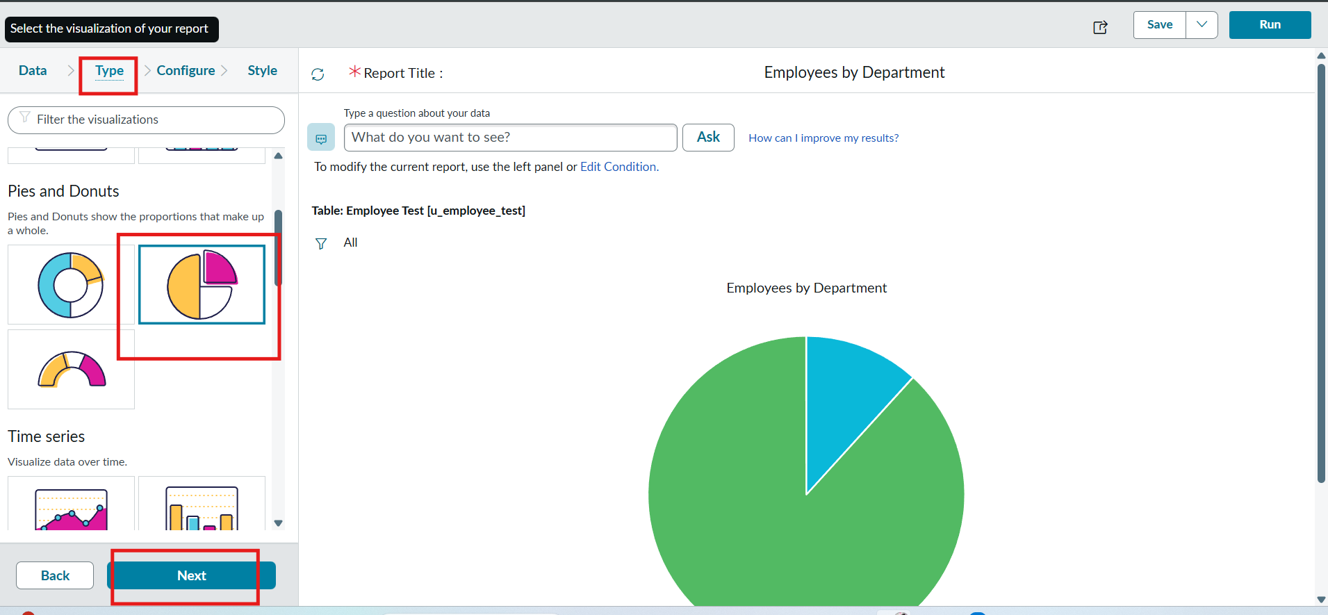
- Now In Configure Select Group by Department Field.
- In the Aggregation Field Select Count.
- Then Click next.

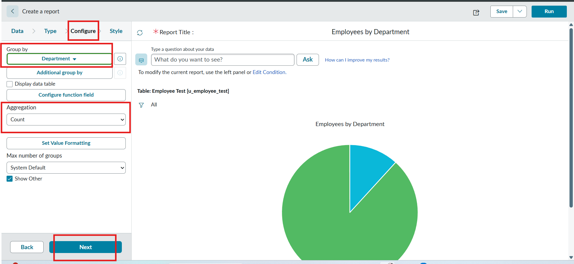
- Now In Style Leave the Chart color by default.
- And Click the Run button to Execute the given data Report.
- And Click save button to Save the Report.
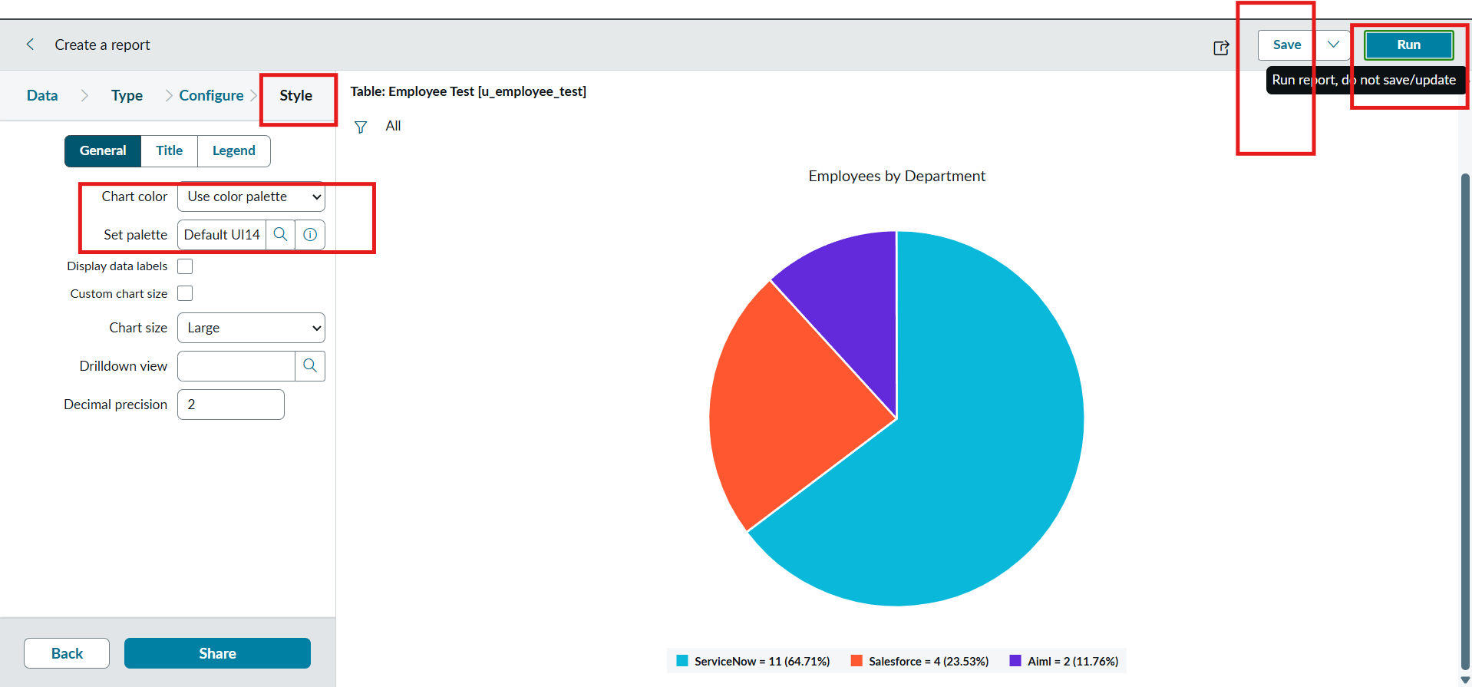

Report 2: Employees by Location
Configuration
- Table: Employee Test
- Type: Bar Chart
- Aggregation: Count
- Group By: Location
Steps :
- Create a New Report.
- Report name : Employees by Location.
- Table Select : Employee Test.
- Select Type : Bar Chart.
- In Configure Select Group by Field : Location.
- And Aggregation is Count.
- Now Click Run to Execute the Report and Click the Save to save the Report.
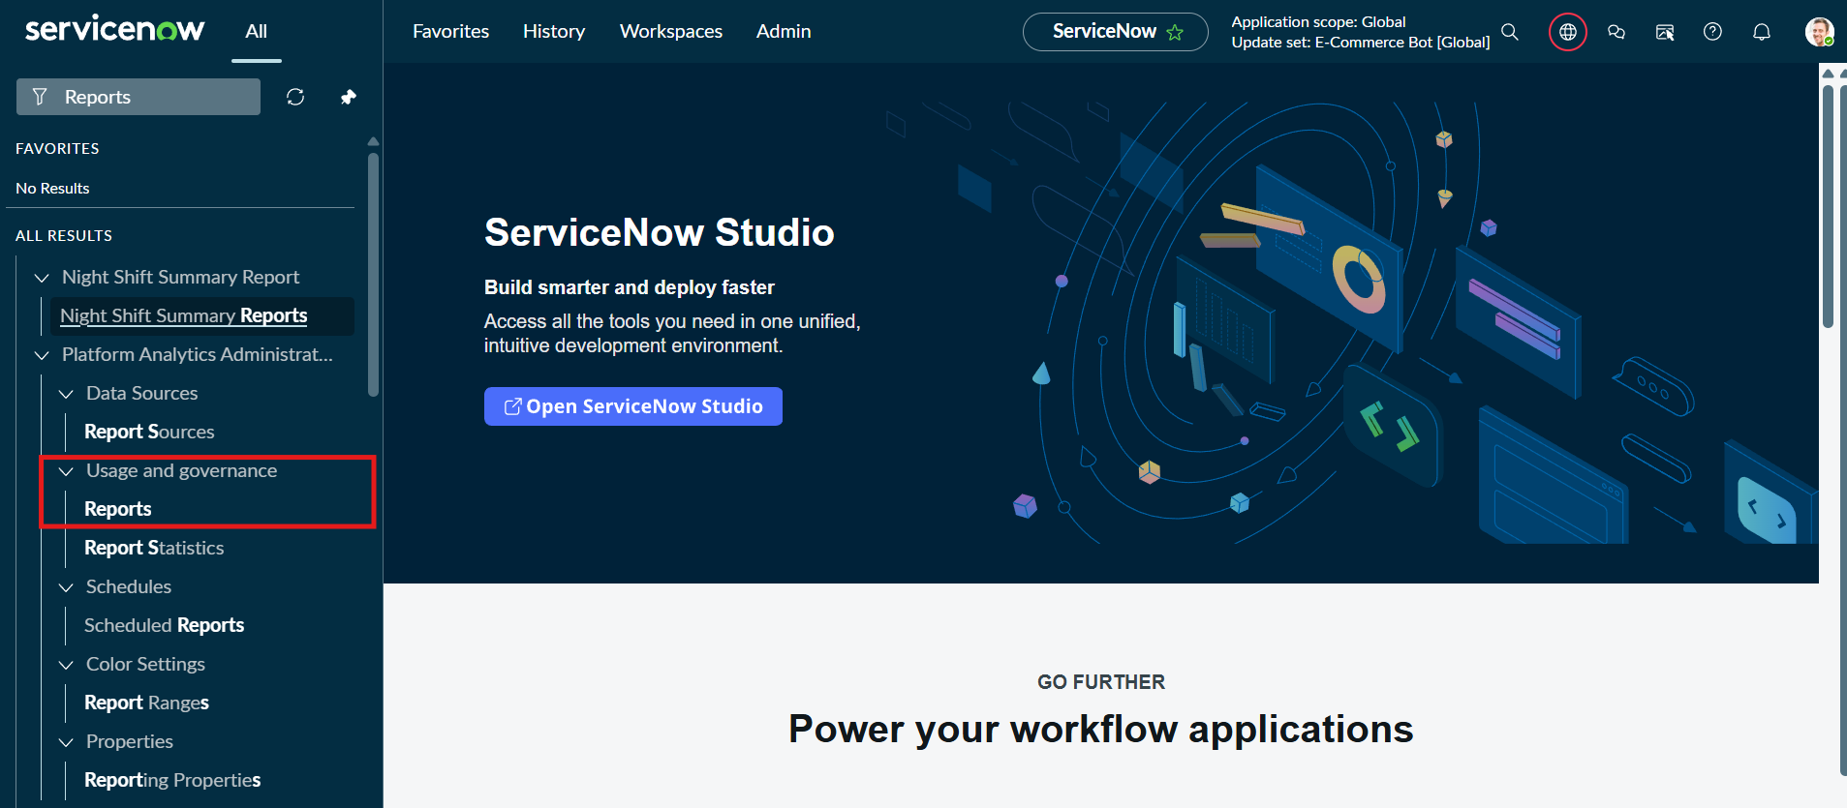
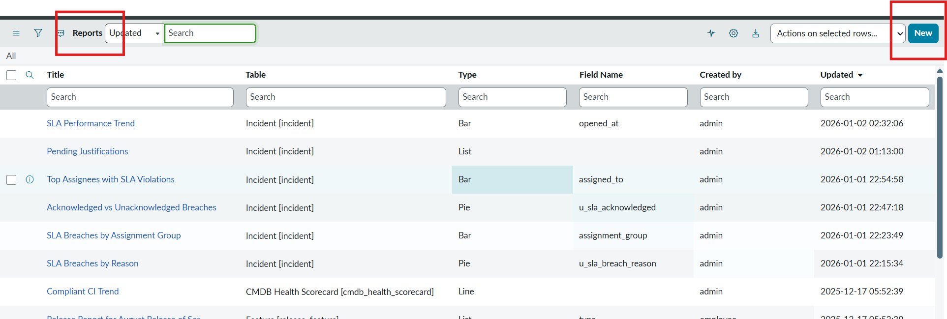

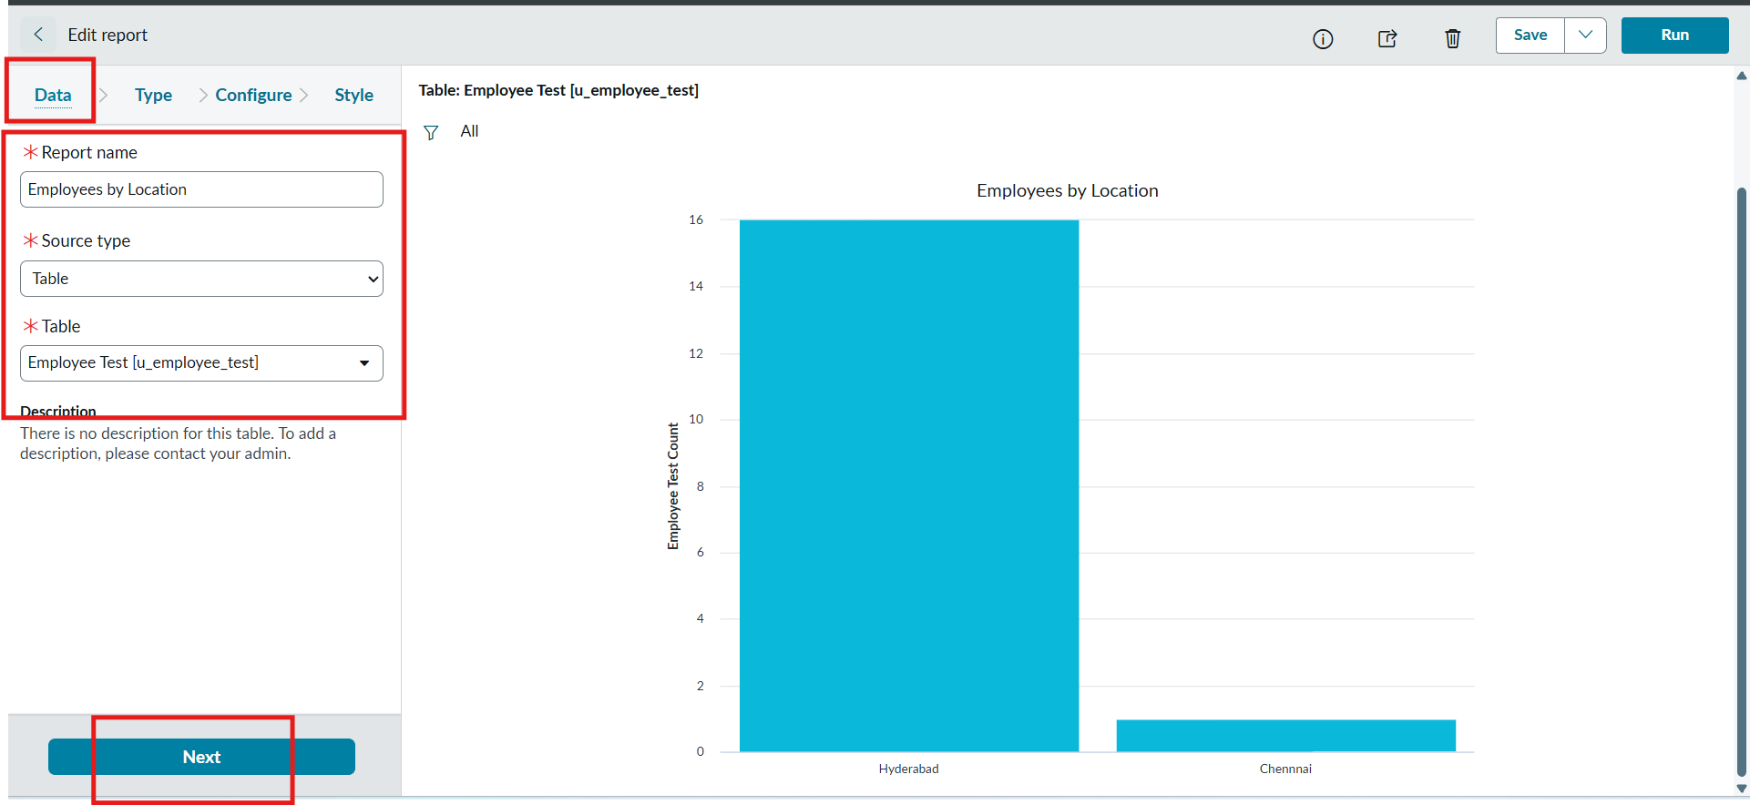
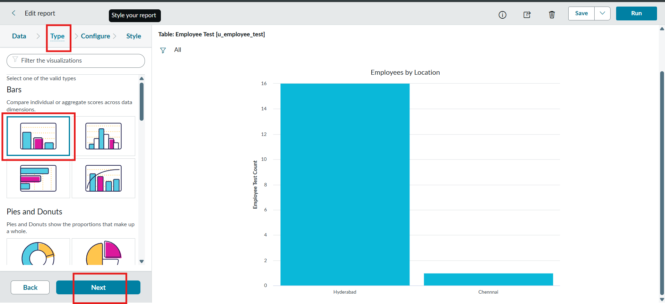
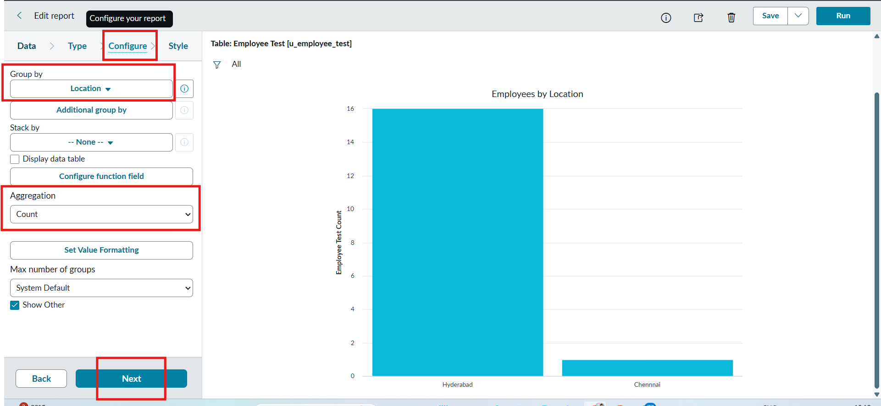

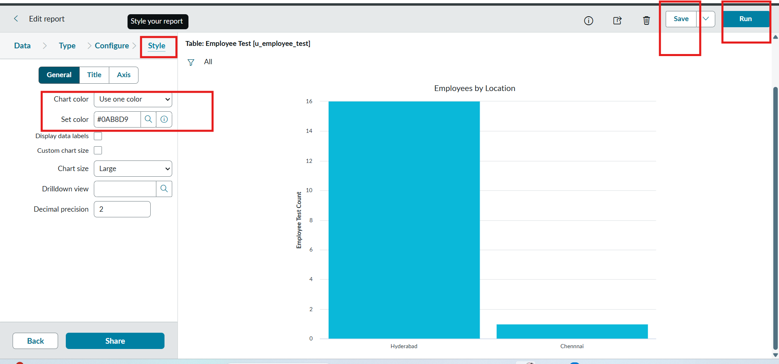

Report 3: Employee List Report.
Configuration
- Create a New Report name : Employee List Report.
- Table: Employee Test.
- Select Type: List.
- In Configure Select Columns:
  - Employee ID.
  - Employee Name.
  - Email.
  - Department.
  - Location.
- Now Select next and no required to choose anything in Style.
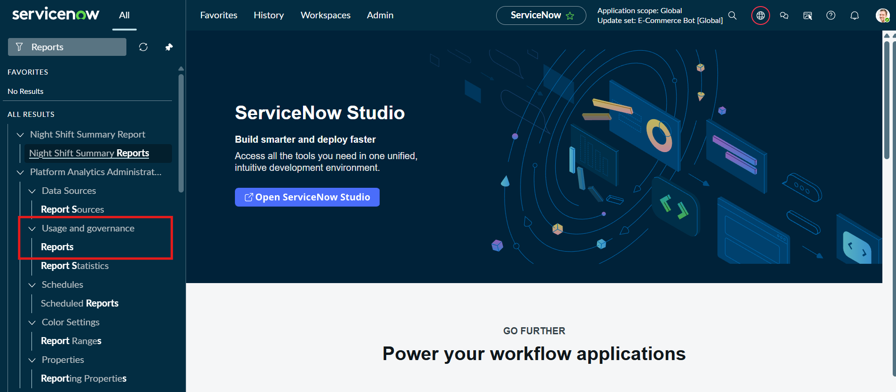
- Now Click Run to Execute the Report and Click Save to Save the Report.
